Maurits Pieper on Norwayomega

Hi, my name is Maurits Pieper. As an ex professional basketball player, signing my first contract when I was 17, I represented the professional team of Amsterdam and the Dutch National Team.

Currently based in London, I work in venture capital in my family business. Not only for me as an athlete health is of utmost importance but also in my current job, where travelling amongst different time zones became a constant, a healthy diet and the right supplements are crucial. The daily intake of omega 3 keeps me energized and helps to complete my daily nutritional intake. Most obvious health improvements I can report are high stress resistance since Omega 3 is highly valuable for the brain, a strong immune system and as mostly well-known the rich fish oil makes my skin very soft and helps with premature aging.

Omega 3 in phases of recovery

Not only are omega 3 supplements excellent as a preventive measure in a healthy body/mind but it is also very helpful during phases of recovery from injuries.
As for every professional basketball player or athlete, injuries are part of the lifestyle. After my operation due to my knee injury this summer, taking the right nutrition with omega 3 helped me recover much faster and helped improve my sleep during painful nights.

Especially recovering in a vibrant and fast paced city like London, where there is a lot of energy to take in, a balanced, diet and daily exercise, even with my crutches, have helped me to keep my body and mind healthy.

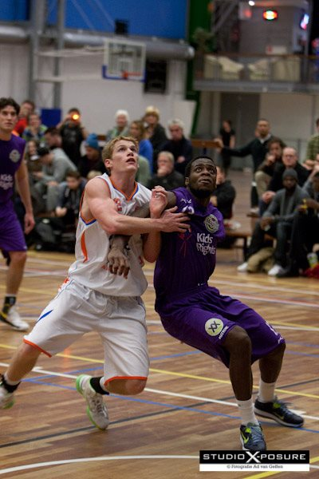

Omega 3 consumption in France

During off season, I train basketball near my family’s vacation house in Nice, France. Since France lies partly by the ocean, the intake of omega 3 through seafood is high.
The recommended 250mg/day by WHO and EU is easily reached and omega 3 supplements are greatly appreciated since consumer awareness is high. In general, after north America, Europe is the biggest market for omega3 supplements and Japan is the smallest.
Norway omega is sold in various pharmacies in the south of France, which makes it easy and convenient for me to keep up with my nutritional routines and helps with my training.

I can highly recommend Norway Omega to all sports enthusiasts or athletes as it reduces muscle tension and muscle loss and burns fats due to increased insulin sensitivity.
Simply put, Omega 3 regulates inflammation and protein functions, therefore greatly supports exercise’s positive effects. It can help athletes or also business managers to become calmer and more stress resistant before a game or an important meeting when giving the best possible performance is essential.

Maurits Pieper

